“Create in me a pure heart, O God,
And renew a steadfast spirit within me.
Do not cast me from your presence
Or take your Holy Spirit from me.
Restore to me the joy of your salvation
And grant me a willing spirit, to sustain me.”
Psalm 51:10-12

T
5.””
CALVARY PRESBYTERIAN COMMUNITY CHURCH of Pine River - NEWSLETTER
FEBRUARY 2024
www.bayfieldcpc.org
This Photo by Unknown Author is licensed under CC BY-SA

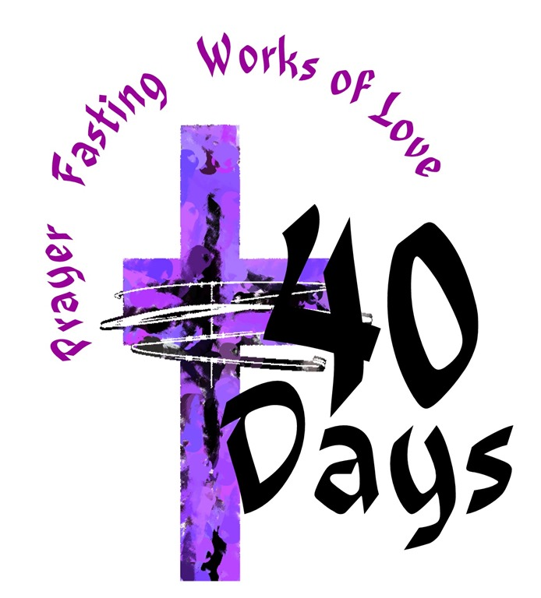

CHURCH CALENDAR
DAYLIGHT SAVINGS SUNDAY, MARCH 10TH
EASTER SERVICES
PALM SUNDAY, MARCH 24TH, 10 A.M.
MAUNDY THURSDAY, MARCH 28TH
(5:30 SOUP 6:30 SERVICE)

GOOD FRIDAY, MARCH 29TH, Noon Service

EASTER
(BREAKFAST 9 AM, SERVICE 10 AM)

SESSION met Wednesday, February 14th.
Elders Carol Blatnick and Brenda Marshall attended the Elder Enrichment day at First Presbyterian Church in Durango. (Nancy attended through an audio recording provided by Pastor Emyrs.) There were 35 in attendance from various churches. A panel of ministers, including Pastor Jane, spoke about “Burning Questions”, Mission, “What Makes Reformed”, Caring in Crisis, Reformed #2, Session.
Do you know what makes us different from other denominations? We believe we are saved because God chose each one of us. We do not have an altar because Jesus is not sacrificed again. We express diversity through music. What we do in worship will attest to scripture.
We have two sacraments. Those sacraments are prescribed and practiced by Jesus. They are Baptism and Communion.
Pastor Jane has added the following: “Much of what makes us different has to do with the way we govern ourselves. It is important that at all levels there is a balance between the clergy and the laity in decision making. Related to this is the practice of having committees rather than individuals make most decisions. As far as worship goes, the practice of a communal prayer of confession is not common. It is an expression of our understanding that not only individuals but also groups and systems may be sinful.
The worship service is to be based in the scriptures for the day.
We encourage lay participation in worship leadership, e.g., leading prayers, scripture reading.
Historically we sang psalms only, but now we worship with music from many sources. The two sacraments we observe (baptism and communion) are to be observed in the community of faith. This means no private observance unless there is an extraordinary circumstance. Even then, there is to be at least an elder present to represent the community. We baptize infants, emphasizing the grace aspect of the sacrament.”

Pastor’s Report: Pastor Jane worked 57.75 hours during month of January, averaging 13.5 hours per week. This included Sunday worship x4, preparation for Sunday x 4 (Sermon, PowerPoint, Bulletin), Sunday school x3, Session meeting, Presbytery Elder Enrichment, Discussion with Presbytery PNC liaison, Telephone calls/emails/texts.
We had 37 members enrolled in 2023. We will have 36 members this year. ZOOM is very worthwhile. Pastor Jane said one or more persons are connected almost every Sunday.

Member Care: Many of our members need our support, encouragement and help. Look and Listen.

Mission & Evangelism: There have been smaller hats distributed to BEEP and the elementary school. Backpacks were given where needed.
WISH LIST
New Sanctuary carpet***Replace faded pictures in the Sanctuary
New large Cross behind the pulpit***Electronic sign outside***White fold-up tables in Berry Hall
More Banners***Cabinets the north end of Berry Hall
Painting Sanctuary interior***Refinish front doors
Newer Printer for office
Do you have suggestions? Comments? These wishes are there for your consideration!

BUILDING & GROUNDS: Jerry Brown & Judy
There is no building report at this time. We are making progress!

CHRISTIAN EDUCATION: The Wired Word tackles current national and world issues with its positive spin. Brighten your day with this reading!

VBS will accept donations through an account set up by Carolyn Brown. The Browns would also appreciate donations of small bottle caps for VBS purposes.

WORSHIP & TECHNOLOGY: Carol Blatnick February 4 Communion numbered 15.

KITCHEN: Judy There is a balance of $524.62 in the kitchen account.
COMMUNITY CARE & FELLOWSHIP: Nancy Women’s Bible Study begins the Lenten Study February 22, Thursday, noon-1 pm. You are welcome!
This Photo by Unknown Author is licensed under CC BY-NC-ND
“Then you will call on me and come and pray to me, and I will listen to you.” Jeremiah 29:12
PRAYERS:
January 21st: Shane Dawson has heart surgery tomorrow.
Gavin Brown’s fiancée was in car accident. No injuries, but car totaled and she shaken.
Don DeWitt will become great-grandfather again!
Thank you Lord for snow.
May we be good and decent to each other.
A neighbor to Kathleen Delzell (Pam) has been in car accident. No particulars.
January 27th: Continue prayers for Shane Dawson for healing, comfort and strength. We pray his heart will restart with pacemaker.
Nancy’s friend Jerry Arp will consult with new cardiologist the 29th regarding his heart function. He needs patience and strength as he waits for medical advice.
Melanie asks prayers for Ozzie Goldman who is recuperating from cancer, but has shoulder pain. He is 13.
January 30th: Nancy’s friend Jerry received the best news regarding his heart function. He is released for six months from follow up appointments.
February 3rd: from Melanie for Sharon Palmer, the mother of Kiffanie Byrd of Bayfield. She had sepsis and had to be flown to GJ. Pray for recovery.
We pray for healing and recovery for Shane Dawson, now at home.
February 6th: Don DeWitt visited ER for leg and hip pain.
Jayne homebound due to asthma. She was flown to GJ for blocked bile duct. Her treatment was successful.
February 12th: for Shawn Mar’s family following his passing.
For Cathy Roberts and family, whose husband passed suddenly after a fall. Cathy has preached for us when Pastor Jane has been on vacation.
Don DeWitt’s joy in receiving colorful thank yous from children who received bicycles. They are displayed in Berry Hall.
For Callum and family as he searches for answers and direction in his recovery..
For so many widespread problems in our world.
February 15th: May God give Callum and family courage and strength.
Pat and Bill Early need a dose of courage and strength also as Bill recovers from surgery, and as Pat supports Bill as caretaker.
Pray for Pam Dawson to receive healing medication to clear her congestion.
May Jayne Lyday receive beneficial homecare and an abundance of courage during her convalescence from asthma.
We stand with our hardworking friend Lance as he schedules future treatment.

MISSION: Pine River Shares open Monday - Thursday for our food and clothing donations.
PNC: Our ministerial search continues. Nothing new to report.
NEXT SESSION MEETING (by Zoom) IS Wednesday, March 13, 2024 at tbd. Session Elders are Jerry Brown, Carol Blatnick, Judy Norton (Treasurer), Nancy Senti (Clerk) and newest Elder: Brenda Marshall.

